Data Structures Notes
Definition:
A data structure is a specific way of organizing and storing data in a computer. So that it can be accessed and modified efficiently.
Example:
- Array
- Linked List
- Hash Table
- Stack etc.
Pointers:
Pointers are variables in programming (mainly in languages like C and C++) that store the memory address of another variable. Instead of holding actual data, they "point" to where that data is stored in memory.
Why do we use pointers?
- Direct Memory Access: Allows programs to access and modify data directly in memory, improving efficiency.
Syntax:
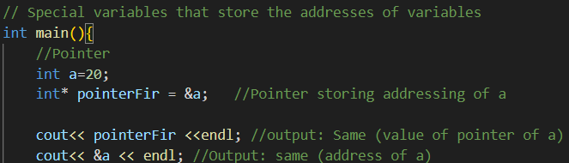
Pointer to Pointer:
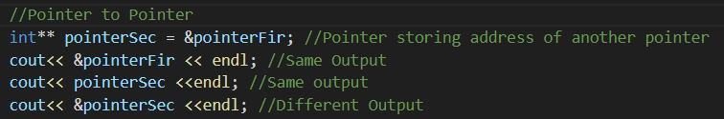
Dereferencing:
Dereferencing a pointer means accessing the value stored at the memory address that the pointer holds. In C/C++, the dereference operator * is used for this purpose.
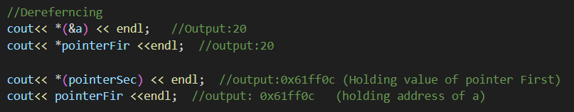
Double Dereferencing:
Double dereferencing involves accessing the value pointed to by a pointer to a pointer. This means you’re following two levels of indirection to reach the actual data.
Null Pointer:
A Null Pointer is a pointer that doesn’t point to any valid memory location. It is typically assigned the value NULL (or 0) to indicate that it’s not currently pointing to any object or data.
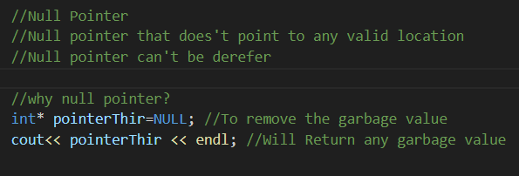
Pointer to Array:
A pointer to an array is a pointer that holds the address of the first element of the array. In C/C++, arrays and pointers are closely related, and the array name itself can act as a pointer to its first element (at index 0). Further an array pointer is a constant pointer that can’t be changed throughout the program.
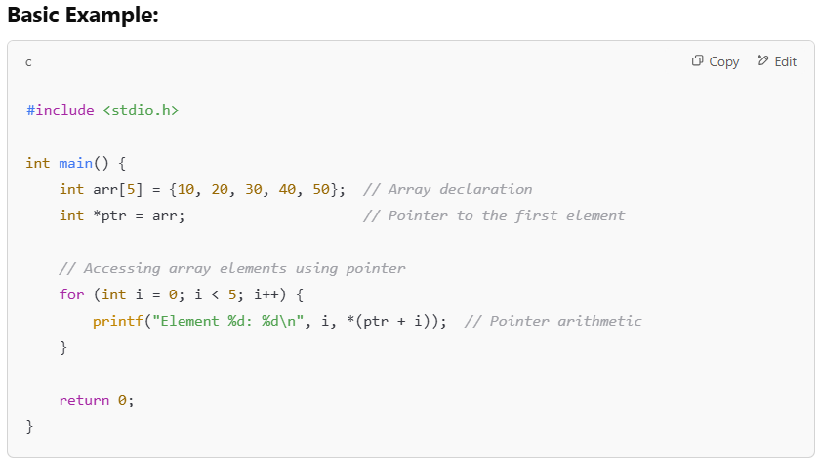
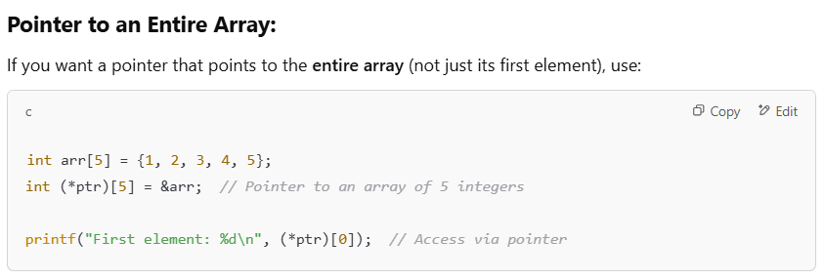
What is meant by constant Pointer?
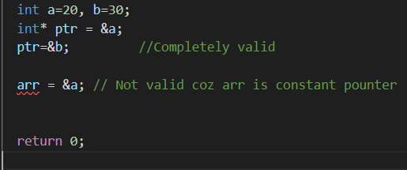
Pointer to Structure:
A pointer to struct is simply a pointer that holds the memory address of a struct instead of its actual data.
What is Stack Allocation?
- Memory is given automatically when you create a normal variable.
- It's fast and easy — you don’t have to manage it.
- Once the function ends, the memory is cleaned up.
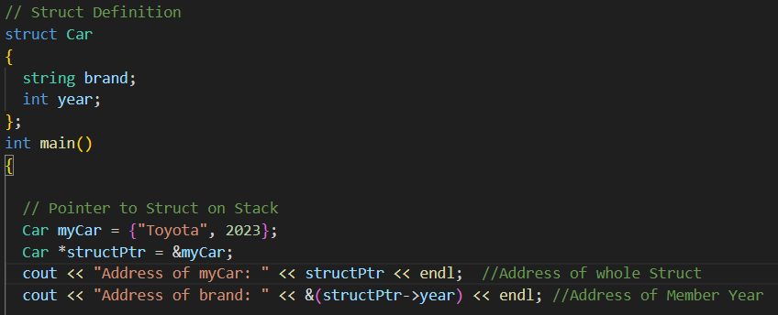
Dereferencing Structure Pointer:
Another way to Dereferencing:
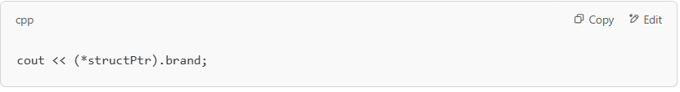
What is Heap Allocation?
- Memory is given when you ask for it using new.
- You need to manually free the memory using delete.
- Useful when you want a variable to stay even after a function ends.
- if you forget to free heap memory, it stays allocated even after the function ends, leading to a memory leak.
- A memory leak happens when your program allocates memory (usually on the heap) but fails to free it when it's no longer needed. As a result, the memory stays "locked" and can't be reused, even though the program no longer uses it
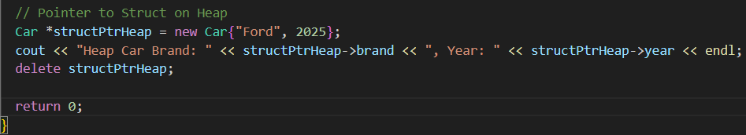
Pointer to Classes:
A pointer to a class in C++ is a pointer that holds the memory address of an object of that class. It allows you to access members (methods and variables) of the class using the pointer.
Heap Allocation:
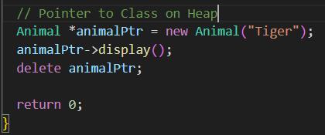
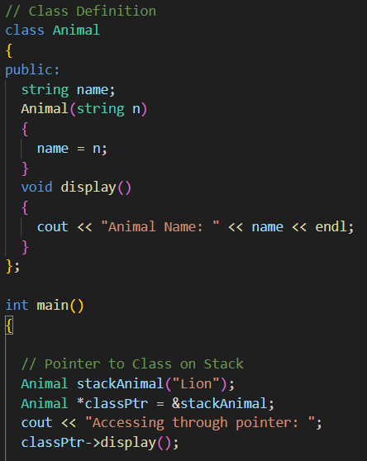
Pointer to Function:
A function pointer is a pointer that stores the address of a function. Just like pointers can point to variables, function pointers can point to functions and can be used to call them.
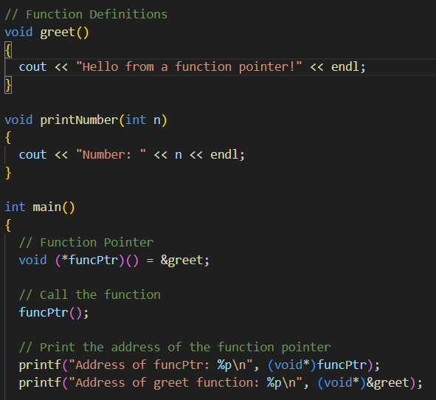
With Parameter:
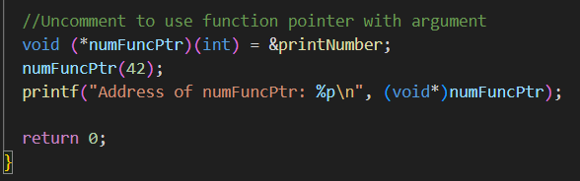

Linked List
This Is a type of Linear Data Structure. Linked List is a way to store a list of items where each item (called a node) holds two things:
- Data – the value you want to store.
- Pointer – a link/reference to the next node in the list.
Types of Linked List
- Singly Linked List – nodes point only to the next node.
- Doubly Linked List – nodes point to both the next and previous nodes.
- Circular Linked List – the last node points back to the first node, forming a circle.
Benefits:
- Dynamic size
- Efficient insertions and deletions
Drawbacks:
- Extra memory for pointers
- Sequential access, no direct access to elements
Why Searching is Slow in Linked List?
No Direct Access: You can't jump to a specific node directly (like in arrays). You have to start from the head and go node by node.
In a linked list, nodes are placed randomly in memory (non-contiguous), and each node has a pointer to the next one. When searching, the CPU has to:
- Access the first node.
- Follow the pointer to the next node.
- Repeat this process until it finds the target or reaches the end.
This is called pointer chasing, and it's slow because:
- The CPU can't predict where the next node is.
- It can't load multiple nodes into the cache at once, leading to cache misses.
Key Points:
- Non-contiguous memory (nodes connected via pointers).
- Head-Always Point the first node of the linked list
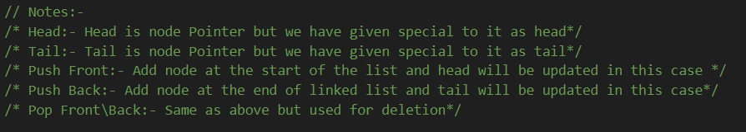
Notes:

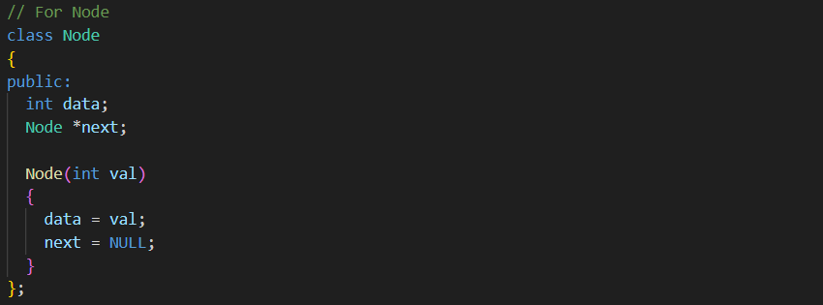
Insertion at the Start of Linked List\Push-Front
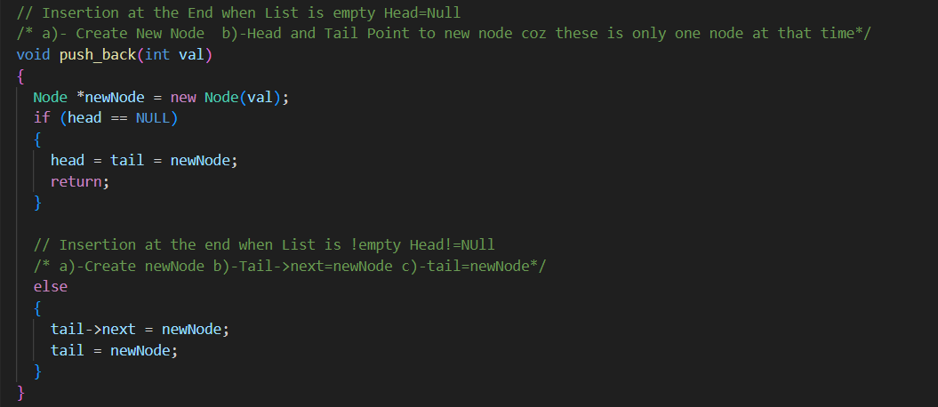
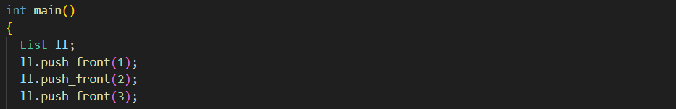
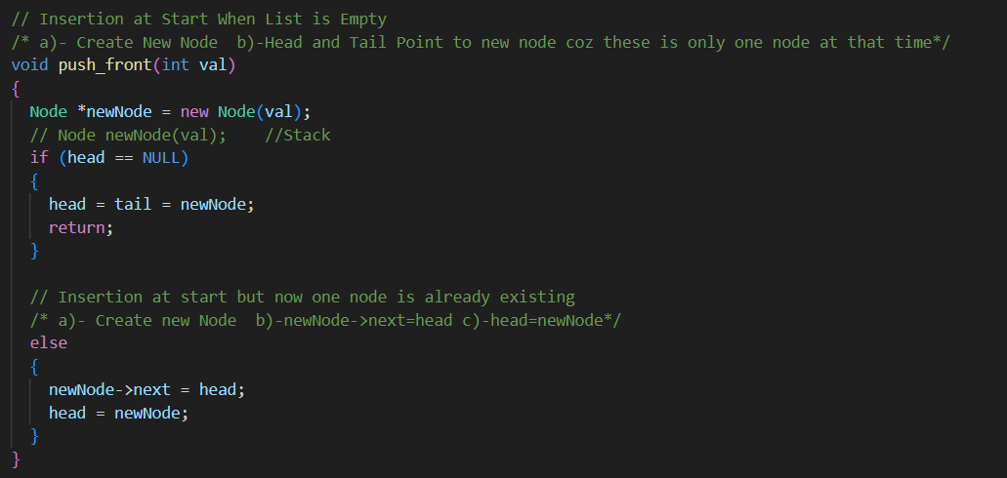
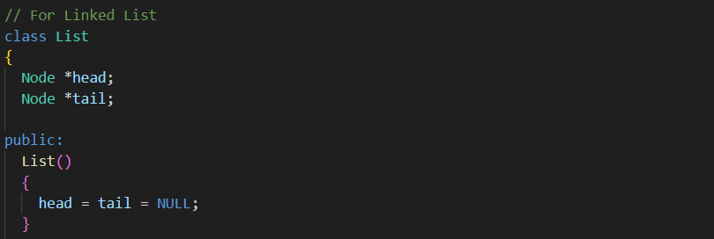
Insertion at the end of Linked List\Push-Back
Deletion from the Start\Pop-Front
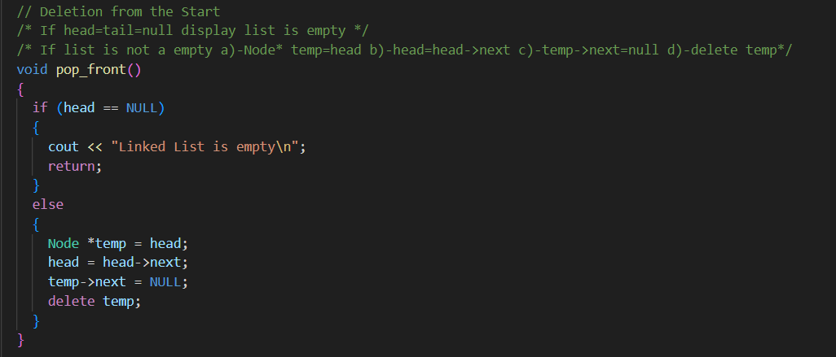
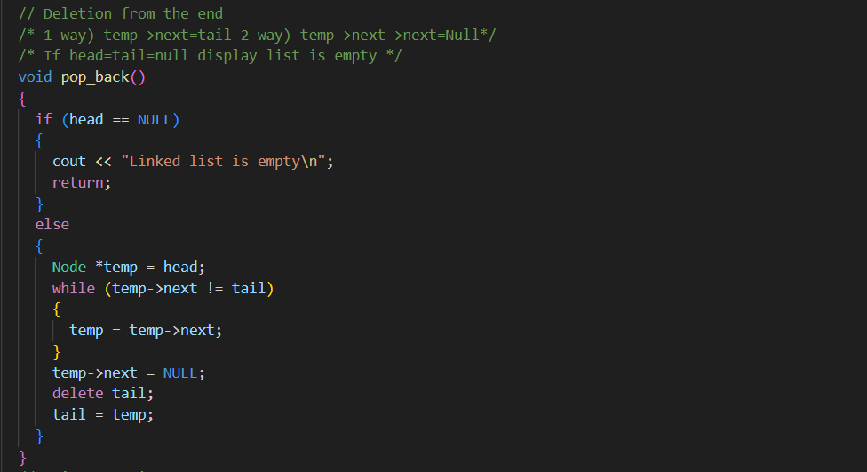
Deletion from the End\Pop-Back

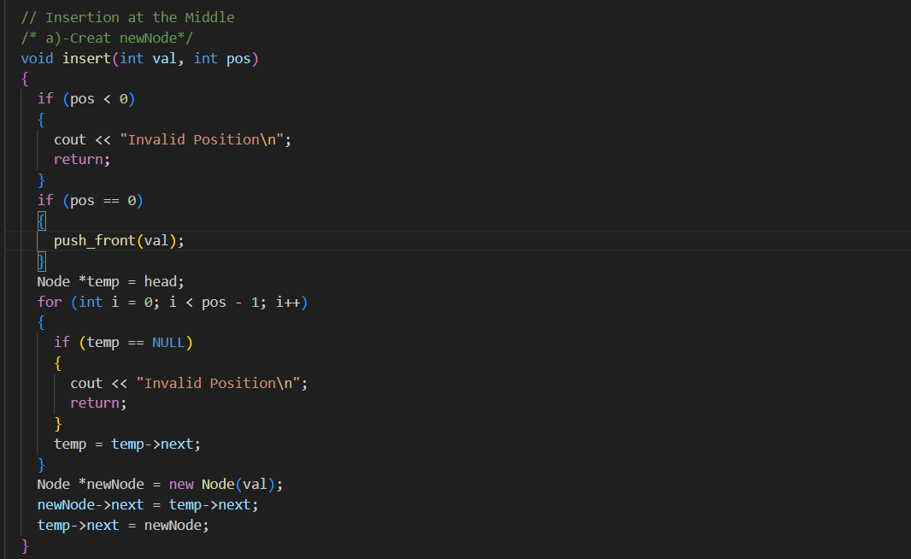
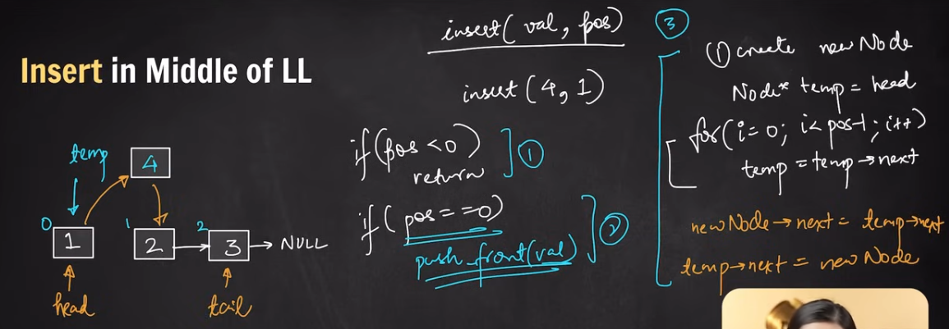
Insertion in the Middle of Linked List

Print Function
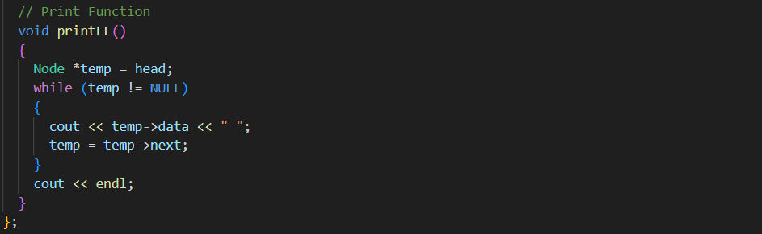
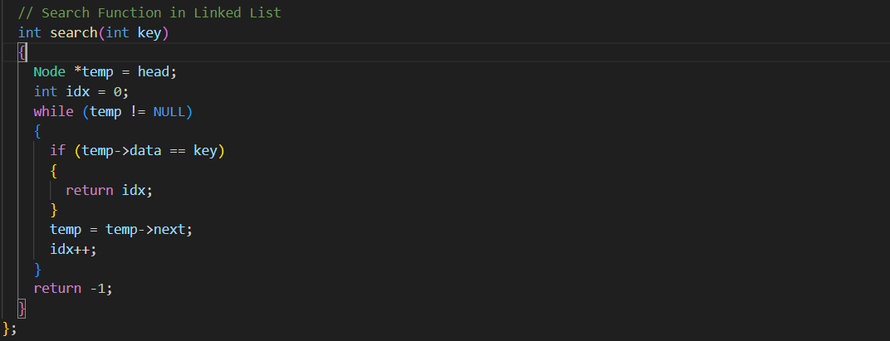
Search Function in Linked List

Stack
A stack is a data structure that follows the LIFO (Last In, First Out) principle. This means that the last item added is the first one to be removed.
Real-life Example of a Stack
A common real-world example is a stack of plates in a cafeteria:
- The last plate placed on top is the first one taken off.
- You cannot remove the bottom plate without first removing the ones above it.

How UNDO Works
The UNDO functionality is implemented using a stack, following the LIFO (Last In, First Out) principle.
Step-by-Step Process
- Perform an Action → Every action (typing, deleting, formatting) is pushed onto a stack.
- Press UNDO → The most recent action is popped from the stack and reversed.
- Press REDO (optional) → The undone action is pushed onto a redo stack so it can be reapplied if needed.
Example: Text Editor UNDO
Let's say you type "HELLO":
- "H" → Push to stack
- "E" → Push to stack
- "L" → Push to stack
- "L" → Push to stack
- "O" → Push to stack
If you press UNDO, the last letter "O" is popped from the stack, removing it from the text.

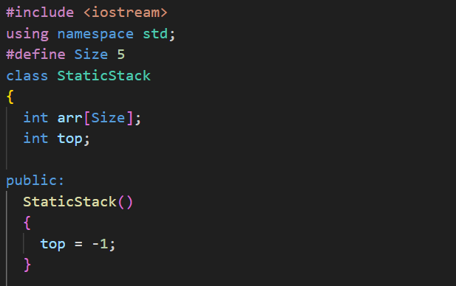
Implementation through Array

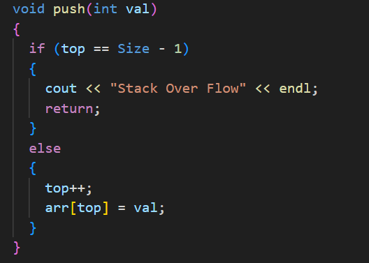

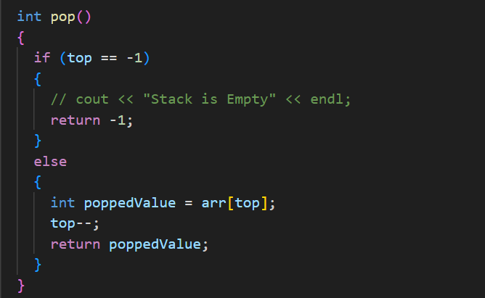

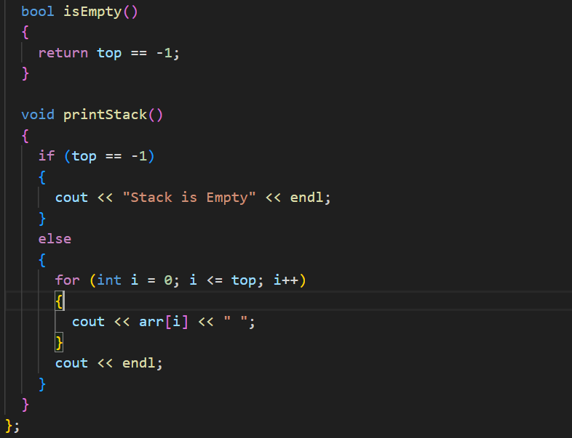
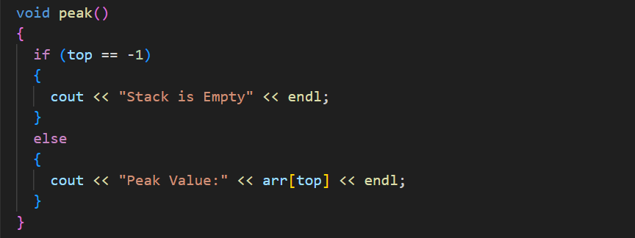

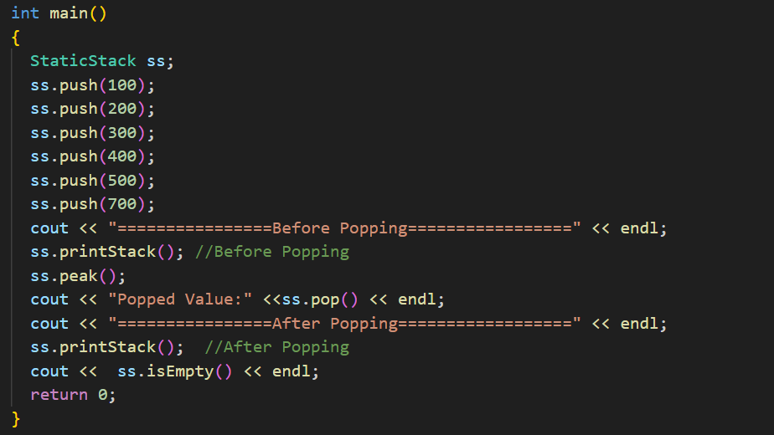

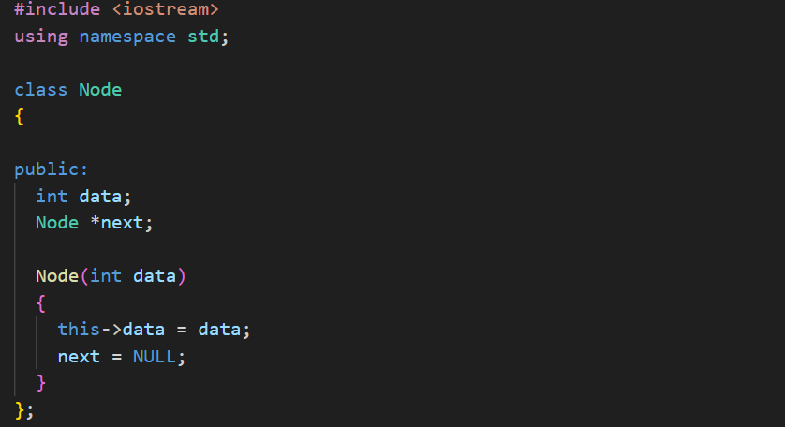
Implementation Through Linked List

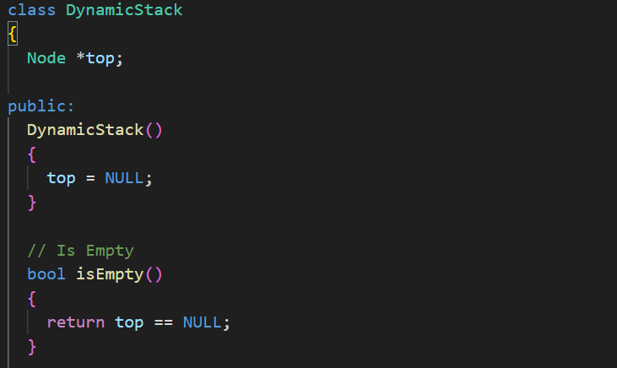

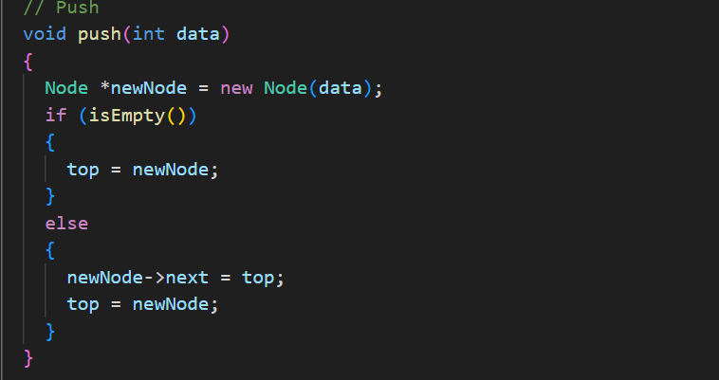

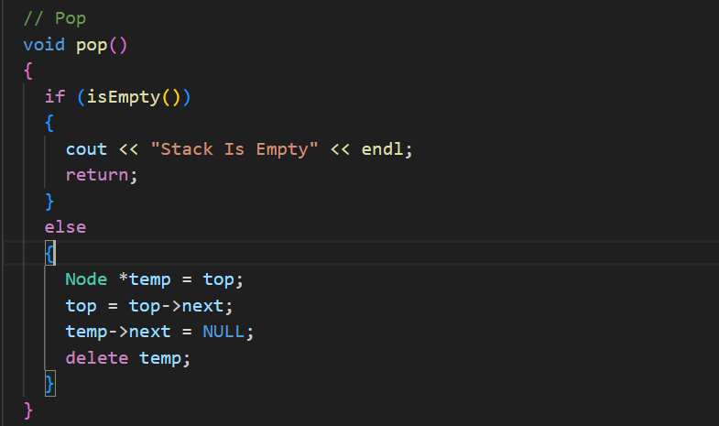

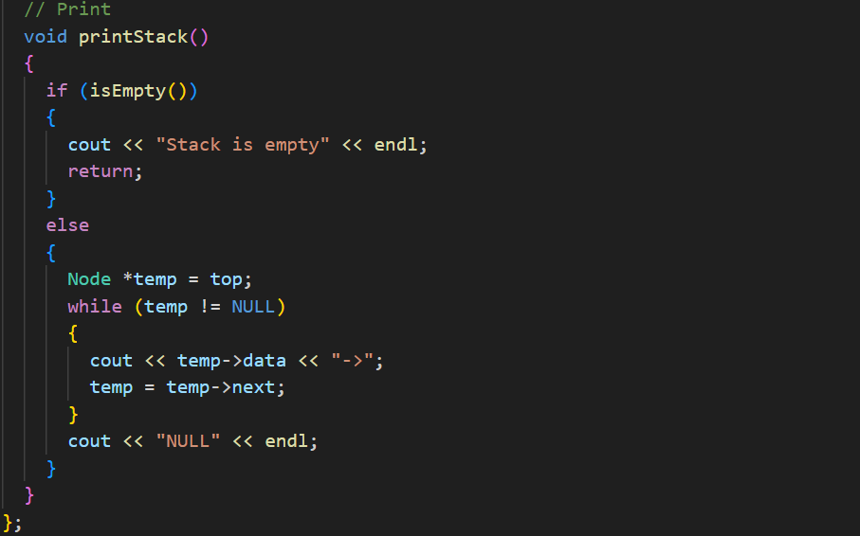
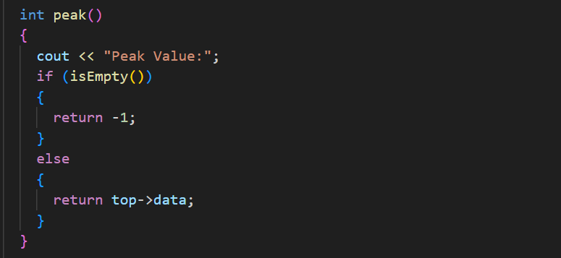

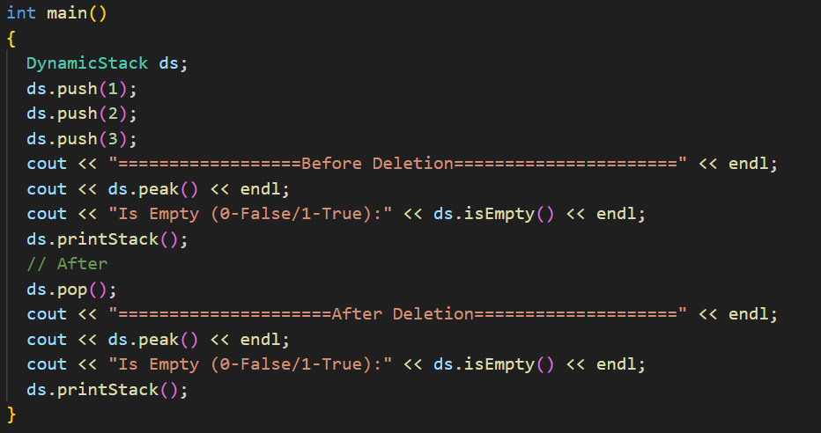
Infix to Post fix Conversion
